Future forms – summary chart
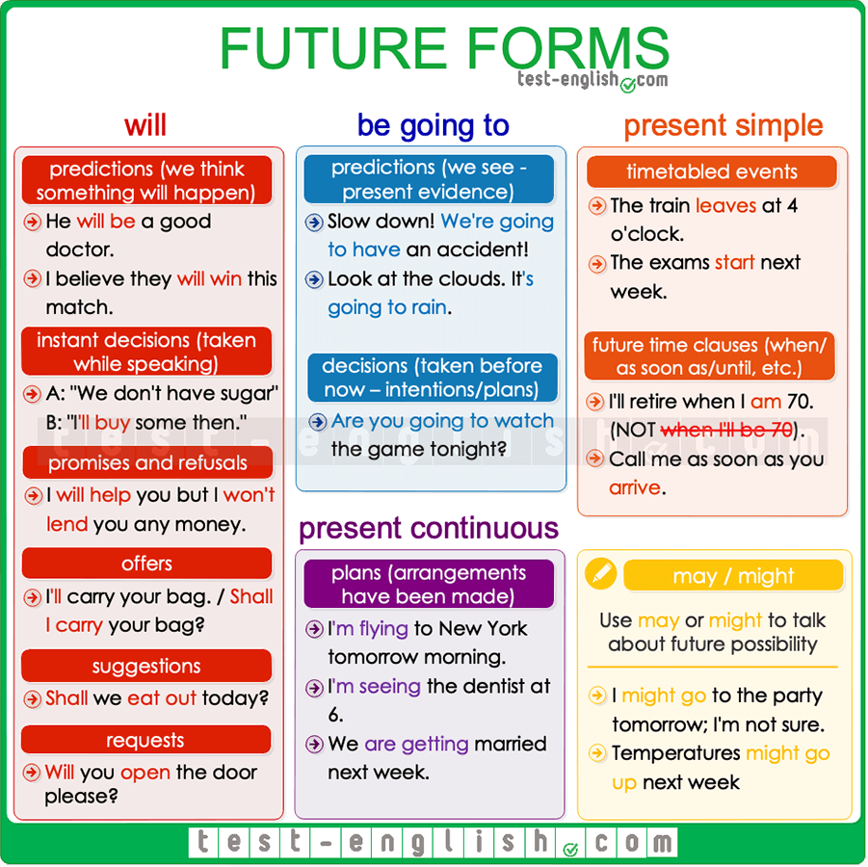

Predictions
We use will to talk about something we think that will happen:
- I think he’ll win the election. I don’t think he will win the elections
- He will be a good doctor.
We use be going to to talk about something that is very near to happen or that we see is going to happen (there is present evidence)
- Don’t drive like a crazy man. We’re going to have an accident!
- The doctor said I’m going to have a girl.

Decisions
We use will for decisions that we take at the moment of speaking (instant decisions).
- ‘Oh, we don’t have sugar.’ ‘Don’t worry, I’ll buy some.’
We use be going to for decisions that we have already taken at the moment of speaking (intentions or plans).
- ‘Why are you undressing?’ ‘Because I’m going to go to the swimming pool.’

Arrangements
We often use the present continuous to talk about future events that are already planned or decided. When we use the present continuous for arrangements, we must always include when (at 7, this evening, next month, etc.) in the sentence.
- I’m seeing the dentist at 6.
- We are getting married next week.
- I’m flying to New York tomorrow morning.
We can also use be going to for future arrangements.
- I’m going to play tennis with Elisabeth today.

Future time clauses (when, as soon as, until, before, after)
Use the present simple to talk about the future in sentences with when, as soon as, until, before, after.
- I’ll retire when I’m 70. (NOT when I’ll be)
- I won’t call you until I arrive (NOT will arrive.)

Other uses of will

Promises and refusals

- I will help you whenever you need me.
- I won’t lend him my car.

Future facts

- The president will visit the Vatican next November.

Offers
We use I will in statements or shall I in questions.
- I’ll carry that bag for you.
- Shall I organise the meeting?

Suggestions
We use shall we…?
- Shall we eat out today?

Requests
When we ask someone to do something for us.
- Will you open the door, please?

may or might as a future form
We use may or might for possible actions in the future (when ‘we are not sure’). Compare:
- I’ll be late for dinner today. (=I am sure.)
- I might be late for dinner today. (=It’s possible, but I am not sure.)
- I’m going to Denmark next September. (=Sure.)
- I might go to Denmark next September. (=Not sure.)
We use may or might for things that will possibly happen in the future, but we are not too sure. It’s like a prediction about something that we think perhaps will happen.
- The economy might suffer a global recession next year.
- Temperatures may go up next week.
We use may or might not for actions or things that will possibly not happen.
- She looks very tired. She might not come with us.
- We may not have enough time to finish the report for tomorrow.

