

**Test № 1**

**I Future continuous:**

1. This time next week I ___________________ (lie) on a beach in Miami.
2. When I get home from work tonight, my kids ___________________(play) video games.
3. 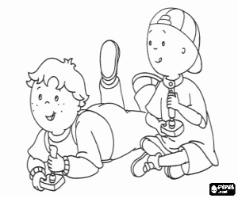What ___________________ you ___________________ (do) in ten years’ time?
4. At this rate, they ___________________(speak) French fluently in six months.
5. Don’t phone between 8 and 9. They ___________________ (have) dinner then.
6. ___________________ you ___________________ (use) the laptop computer this afternoon? I’m going to need it.
7. She ___________________(leave) school this time next year.

**II Future simple VS Future continuous:**

1. I ______________ (work) in the garden all day long tomorrow.
2. 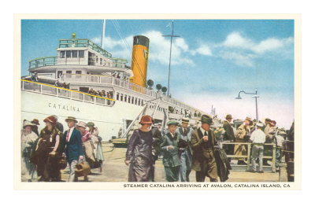I _____________ (finish) the book by the evening.
3. Не ______________ (be) tired after his work.
4. He can't come at two o'clock tomorrow because he _____________________ (work) at that time.
5. Не _______________ (send) us a telegram as soon as the steamer arrives.
6. While my mother is having her breakfast. I _____________ (read) the newspaper.

Steamer *Catalina* arriving at Avalon

**III Fill in with: Present Continuous, Present Simple, Future Simple, Future Continuous**

1. The course ………………………. (begin) in October.
2. You can’t come with me. Dad ………………….. (not / let) you.
3. This time next week I …………………… (have) breakfast with my sister in Paris!
4. Do you have any plans for tonight? – Actually, I do. I ……………………… (go) out with Penny.

**IV Answer the questions in writing. What tense did you use?**

1. Imagine yourself being now on the other planet. What are you doing there?_________________________________________

______________________________________________________________________________________________________________________________

1. What do children usually do in the street? _____________________________________________________________________________

________________________________________________________________________________________________________________________________

1. What were you doing yesterday from 5pm. To 8pm.?________________________________________________________________

__________________________________________________________________________________________________________________________

**Test № 2**

**I Future continuous:**

1. People in refugee camps ___________________(not live) in better conditions in five years’ time.
2. If we get there late, they ___________________(sleep)
3. You can call now because they ___________________(not sleep).
4. This Sunday, ___________________ you ___________________(play) squash with Liam as usual?

No, I won’t because he _____________ (get ) married then.

1. ___________________ your brother’s band ___________________((play) at the jazz festival next week?

No, Actually, they _______________(perform) in New York then.

1. We ___________________(not go) on holiday next year unless the economy picks up.
2. We ___________________(not spend) Christmas at our country house if they don’t get the roof repaired on time.

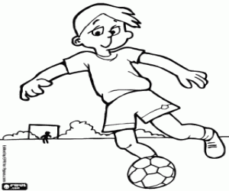

**II Future simple VS Future continuous:**

1. He_________________ (ring) you up and tell you everything about the forthcoming meeting.
2. They _______________________ (not, play) football on Sunday afternoon.
3. He ________________ (carry) this bag for you.
4. In June that firm ______________________ (carry) on negotiations for the purchase of software.
5. In summer the director __________________ (still, work) on her new film.
6. She _________________ (not, go) to the party with us.

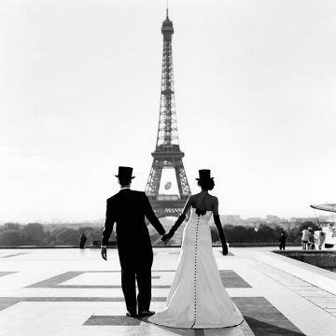**Fill in with: *Present Continuous, Present Simple, Future Simple, Future Continuous***

1. The course ………………………. (begin) in October.
2. You can’t come with me. Dad ………………….. (not / let) you.
3. This time next week I …………………… (have) breakfast with my sister in Paris!
4. Do you have any plans for tonight? – Actually, I do. I ……………………… (go) out with Penny.

**IV Answer the questions in writing. What tense did you use?**

1. Imagine yourself being now on the tropical beach. What are you doing there?_________________________________________

_________________________________________________________________________________________________________________________________

1. What do people do every day at work? ____________________________________________________________________________________

___________________________________________________________________________________________________________________________________

1. What were you doing today from 7pm. To 9pm.?________________________________________________________________________

___________________________________________________________________________________________________________________________________